Problem working on

How does Total Factor Productivity and Welfare-relevant TFP affect GDP or Human Capital (HC)?

Primary objective of this research is to see and analyse the relationship between TFP and WTFP and how the relation impacts on RGDP and Human Capital (HC). It is also aimed at understanding the implications for economic well-being. In simpler terms it investigates how changes in TFP and welfare implications contribute to overall economic growth and societal well-being of individuals.

Rationale

TFP is a variable to measure efficiency of a country with which labour, capital and many other inputs are related and used in production. It can also be termed as driver of long-term economic growth, as moving with technology is prime requirement of the era along with the concept of maximum utility out of in hand resources. Studying the relationship between TFP and Welfare-relevant TFP can provide insights into how improvements in efficiency translate into economic well-being. In-depth findings about these relations between TFP and WTFP and RGDP can promote policy implications, for example, if the research finds that TFP lead to improvement in WTFP and GDP, policy makers would want to focus on policies and strategies to upboost TFP. If there is economic growth (RGDP) without improving welfare, such development might not be sustainable. Hence understanding the relationship between them can help make informed decisions on sustainable development strategies. TFP is closely linked to sustainable development. Enhancing TFP, which refers to the accumulation and improvement of productivity factors, is an effective approach to optimizing economic development (Zheng et al., 2023). Moreover, TFP is one of the processes that should not be considered independent from the Sustainable Development Goals and underlying approaches such as human development, sustainable development, inclusive growth, and green economy (SDG UN Org). Also connecting to social aspect of sustainable development, the unequal growth of RGDP and TFP compared to WTFP can showcase the existence of inequality. If increases in TFP and Real GDP do not lead to improvements in Welfare-relevant TFP, it could indicate that the benefits of economic growth are not being evenly distributed.

Variables Chosen and reason

Rgdpe and rgdpo = Measures of real gross domestic product(rgdpe) is expenditure – side real gdp at chained PPP. Rgdpo is output side real gdp at chained PPP (Wikipedia, Investopedia, cran.r-project.org). These variables were chosen as they provide outlook on a nation’s overall economic activity.

Emp = Employment, measure of number of persons engaged in the economy. It is a measure of labour resource availability and determines health of an economy by signifying the working class.

Ctfp and cwtfp = most important variables in the study as the whole hypothesis or argument lies on the relationship between these and rest. These variables represent Total Factor Productivity (TFP) at current PPPs (Lan & Zhu, 2023; Zhou & Ji, 2023), ctfp is the TFP level, while cwtfp is the welfare-relevant TFP levels (cran.r-project.org). TFP is a measure of how efficiently and intensely the inputs are utilized in the production process. Changes in TFP are usually attributed to technological progress or changes in efficiency.

Labsh = share of labour compensation in GDP. This variable is responsible for providing view into the income distribution between labour and capital.

Hc= most used variable in Penn World Table. Human Capital or defined as a stock variable representing capacity of an individual to produce a sustained flow of income by virtue of his or her education investment(higher studies)(Lovaglio et al., 2016).

Methodology

The methodology is very simple. We find correlations between the variables to answer our question of impact and relation between the listed variables. We first of all deploy and load all the libraries required for the analysis, namely readr, dplyr, corrplot, ggplot2. We then load the dataset to the variable “pwtdata” using the ‘read_csv’ function. Data for one particular year was required. Data from 2014 was chosen as the subsequent years don’t have adequate and accurate data of the variables chosen. We filter the data loaded to show only 2014 data using the filter function. Out of all the variables only few are needed, we select those using the select function and store them in another variable. To eradicate missing values in the variables we first count the number of missing values using is.na functions and then omit them using na.omit function and store the thus continuos data in a new variable “omiteddata”. We then use the inbuilt summary feature to showcase a raw picture of the data. It shows an overview of descriptive statistics from the dataset. It shows data like mean, median, min, max and quartiles of the variables.

Note: No country wise analysis is done in the study. A general world level overview of the variables has been performed to assess whether on the larger scale these factors effect each other or not, or what relation do they possess for each other. Any outlier for the said findings can exist and might exist.

Mainly the analysis is based on correlation between the variables to give sufficient evidence to prove that a change in one variable can and does affect the another. Correlation between different variables will give different arguments and conclusions which can be interpreted. Correlations aimed to do were, ctfp vs cwtfp, cwtfp vs hc, ctfp vs labsh, rgfpo vs cwtfp, and rgdpo vs ctfp.

A correlation heatmap was formed between the variables and their correlations were analysed for relations. Regression analysis was performed to see if the obtained results are accurate and do define the relationship between dependent variables and independent variables.

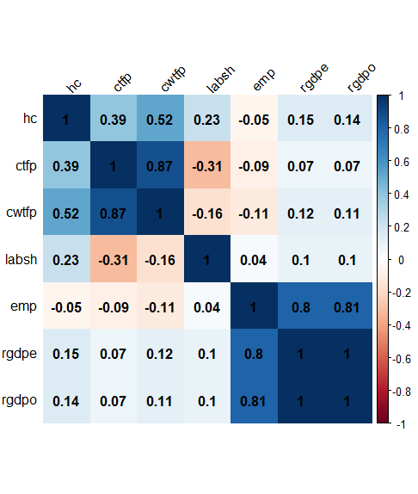

Figure 1Heatmap

Results

The heatmap provides insight into the raw relations between values of each variable. How an increase in one variable increases the other. But doesn’t clearly show what factors influence it. For that regression analysis is done.

cwtfp ~ hc: This model is predicting cwtfp based on hc. The coefficient for hc is 0.16156, which means for each unit increase in hc, cwtfp increases by 0.16156 units, on average. The p-value is less than 0.001, indicating that hc is a significant predictor of cwtfp. The R-squared value is 0.2727, meaning that approximately 27.27% of the variance in cwtfp can be explained by hc.

Figure 2. Welfare R TFP vs HCI

cwtfp ~ ctfp: This model is predicting cwtfp based on ctfp. The coefficient for ctfp is 0.58533, which means for each unit increase in ctfp, cwtfp increases by 0.58533 units, on average. The p-value is less than 0.001, indicating that ctfp is a significant predictor of cwtfp. The R-squared value is 0.7586, meaning that approximately 75.86% of the variance in cwtfp can be explained by ctfp.

Figure 3. WTFP vs CTFP

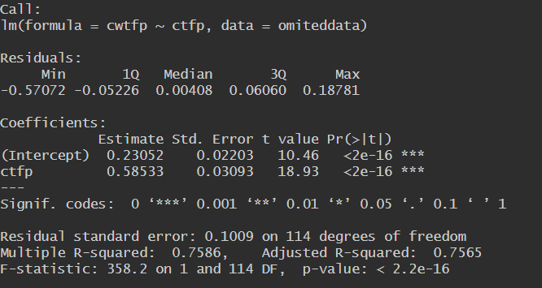

Figure 4. Regression Analysis of WTFP vs CTFP

labsh ~ hc: This model is predicting labsh based on hc. The coefficient for hc is 0.04243, which means for each unit increase in hc, labsh increases by 0.04243 units, on average. The p-value is 0.0131, indicating that hc is a significant predictor of labsh. The R-squared value is 0.05284, meaning that approximately 5.284% of the variance in labsh can be explained by hc.

Figure 5. LABSH vs HCI

Figure 6. Regression Analysis of LABSH vs HC

labsh ~ cwtfp: This model is predicting labsh based on cwtfp. The coefficient for cwtfp is -0.09696, which means for each unit increase in cwtfp, labsh decreases by 0.09696 units, on average. The p-value is 0.0814, which is greater than 0.05, indicating that cwtfp is not a significant predictor of labsh at the 5% significance level. The R-squared value is 0.0264, meaning that approximately 2.64% of the variance in labsh can be explained by cwtfp.

Figure 7. LABSH vs WTFP

Figure 8. Regression Analysis of LABSH vs WTFP

labsh ~ ctfp: This model is predicting labsh based on ctfp. The coefficient for ctfp is -0.12533, which means for each unit increase in ctfp, labsh decreases by 0.12533 units, on average. The p-value is less than 0.001, indicating that ctfp is a significant predictor of labsh. The R-squared value is 0.09767, meaning that approximately 9.767% of the variance in labsh can be explained by ctfp.

Figure 9. LABSH vs CTFP

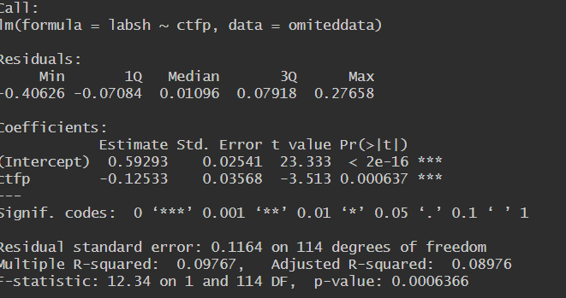

Figure 10. Regression Analysis of LABSH vs CTFP

Conclusion

The study was aimed to analyse the relation between total factor productivity (TFP). Welfare-Relevant TFP (WTFP) Real GDP(RGDP), and Human Capital (HC). The findings from the both the analyses give us some insight as to what the data says about itself. These findings provide evidence that changes in TFP and WTFP can impact RGDP and HC. They also highlight the importance of considering welfare implications when assessing economic growth. If increases in TFP and RGDP do not lead to improvements in WTFP, it could indicate that the benefits of economic growth are not being evenly distributed, which could have implications for sustainable development strategies. Further when regression analysis was done it was found that in more depth, other factors may influence these relationships. It's also important to note that these findings are based on a general world level overview, and there may be outliers or variations at the country level.